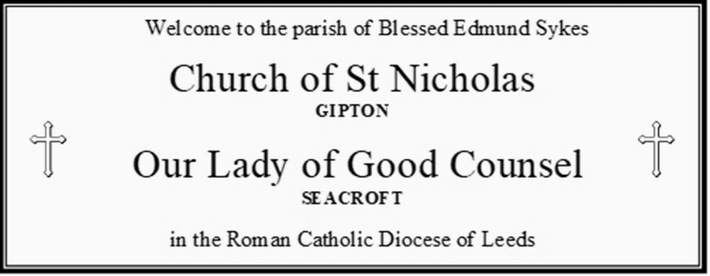
Parochial Administrator: Fr Craig Fitzpatrick
St Nicholas Presbytery, Oakwood Lane, LEEDS, LS9 6QY
Email: pp.blessededmundsykes@dioceseofleeds.org.uk Tel: 0113 249 0429

11th Sunday in Ordinary Time
18th June 2023
This weekend | Saturday | St Nicholas | 6.00 pm | 11th Sunday in ordinary time | Bridget & Alf  Holman
This weekend | Sunday | St Nicholas | 9.30 am | 11th Sunday in ordinary time | People of the Parish  (special prayers for James Byrne)
This weekend | Sunday | Our Lady’s | 11.00 am | 11th Sunday in ordinary time | Pauline Beattie
This Week | Monday | St Nicholas | 9.10 am | Weekday Ordinary Time | Margaret Kelly
This Week | Tuesday | Our Lady’s | 10.00 am | Saint Alban  First Martyr of England | Alan Weeks
This Week | Wednesday | NO MASS | NO MASS | NO MASS | NO MASS
This Week | Thursday | Our Lady’s | 10.00 am | Ss John Fisher & Thomas More | Sheila Lambert
This Week | Friday | St Nicholas | 9.00 am | Weekday Ordinary Time | Josie Heal
Next Weekend | Saturday | St Nicholas | 6.00 pm | 12th Sunday in ordinary time | Paddy & Maura  Togher
Next Weekend | Sunday | St Nicholas | 9.30 am | 12th Sunday in ordinary time | Joe O’Rourke
Next Weekend | Sunday | Our Lady’s | 11.00 am | 12th Sunday in ordinary time | People of the Parish

THOSE IN NEED OF OUR PRAYERS Special prayers for Eileen Bell, John Haynes & Sheila Haynes, Kathleen Gaughan, Margaret Fitzpatrick, Moira Doyle, Anna Gawlik, Rachel, Adah McHugh, Joan Parry, Josie Smith, Jane (seriously ill), Pat Doolan, Willie McDonagh, Betty Burke
Please remember that there is a story behind everyone named on our sick list. Never stop praying for them.

MASS INTENTIONS RECEIVED THIS WEEK
Pauline Beattie, Anne Brown

If you would like a Mass to be said on a particular date, please submit the Mass request as soon as possible. There is no guarantee that a specific date will be available. Please also stipulate if you would like the Mass to be offered at St Nicholas’ or Our Lady’s church.

LAST WEEK’S OFFERTORY - £392.07 Because Canon Gilligan celebrated our Masses last weekend, the collection from Our Lady’s hasn’t been counted yet!
HOLY HOUR @ OUR LADY’S
Every Friday at Our Lady’s church there will be a Holy Hour from 2-3pm. This is a wonderful opportunity just to spend time with the Lord in our busy lives.

JAMES BYRNE
Because of recent events in Seacroft, Thursday’s anniversary Mass for James Byrne was not said. This Mass will be rescheduled. Please keep the soul of James in your prayers, and please remember him and his loved ones at Mass this weekend.

VISITING
Fr Craig has been asked a couple of times recently if it’s still possible to receive home visits. There is no problem at all with this but he neds to be given the details of those who would like a visit. Please leave a message on the parish answerphone, or hand in the details on a piece of paper.

NEWS FROM THE PARISH

SVP
The SVP offer sincere thanks for the collection at the funeral of Pauline Beattie, may she rest in peace. A marvellous £554.25 has been sent to the society.

BUILDINGS
Saint Nicholas
Work is now complete to the roof above the altar and thankfully we no longer have leaks. In addition, we have had the steps to the main entrance re-set to minimise trip hazards.

We now have authorisation from the Diocese in respect of the next external works at St Nicholas. This will involve roofing, joinery and external decoration to 2 aspects of the building.
Conversations continue about the former baptistry tower and roof. We are sorry we still cannot give you positive news.

Our Lady’s
A new door has been fitted at the side of church into the sacristy area.
To minimise trip hazards, the steps at the front of church have been re-set and marked. Uneven paving from the pedestrian gate has also been rectified.

NEWS FROM THE DIOCESE

Nazareth Summer Picnic
25th June. 12-4 pm. Hinsley Hall. Family day of fun. £10 donation per family. Please book -
d.roman@leedstrinity.ac.uk

NOVENA TO OUR LADY OF UNFAILING HELP
18th – 26th June @ Leeds Cathedral, Monday-Friday 6.15pm, Saturday & Sunday 5pm

Pro-Life
Walsingham Pilgrimage. Saturday 5th August. Pick up at Shipley, Harehills and Crossgates. Speak to Kate on 07505 767415 or see – www.prolifepilgrimage.org.

POPE FRANCIS’ MONTHLY PRAYER INTENTIONS – June
For the abolition of torture
We pray that the international community may commit in a concrete way to ensuring the abolition of torture and guarantee support to victims and their families.

